**Project Name : Gas Monitoring And Alerting System**

Team Lead : M.Ravinesan

Team Member1 : M.Sivanantham

Team Member2 : S.Sathish

Team Member3 : R.Vijay

**CREAT THE IBM WATSON IOT PLATFORM AND A DEVICE:**

# Creating device type:

sensors with Watson IoT Platform. Each device that is connected to the IBM Watson IoT Platform must be associated with a device type. Device types are groups of devices that.Before you perform this task, you must have an IBM id so you can log in to Watson IoT Platform.

You must determine which sensors are linked with which assets. You must register the

## Procedure:

* Watson IoT In Platform, go to the **Devices** menu and click the

**Device Types** tab. Click **Add Device Type**.

* Enter a name and description for the device type and then click

**Next**.

* Optionally enter more information about the device type and then click **Done**.
* Click **Register Devices** to register devices with this device type.
* Enter a device ID in the **Device ID** field and then click **Next**.
* Add information about the device and then click **Next**.
  1. In the **Authentication Token** field, enter the Watson IoT Platform API token and then click **Next**.

You can get the Watson IoT Platform API token from the Maximo APM - Predictive Maintenance Insights SaaS welcome letter.

* 1. Verify the information and then click **Done**.

# INTRODUCTION :

IoT platforms provide many integrated services and infrastructures like data storage, connectivity, display, control etc. Hence, they reduce the amount of investment required to deploy IoT solutions and this is one of the main reasons behind some of the most successful IoT solutions around. IBM Watson IoT platform is an industry grade IoT platform frequently used by big industries to store and analyze the data gathered from IoT devices.

Tap Link could be used as a facilitator for connecting your device to IBM Watson IoT Platform. In this tutorial we will setup an IBM Watson account, connect a Tap Link and connect IoT Studio to it.

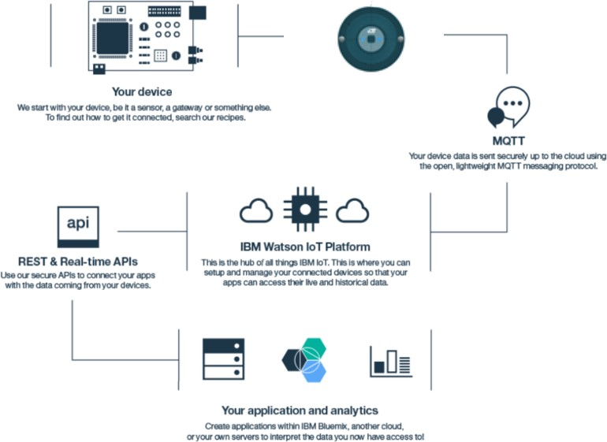

Watson architecture:

Step1: Setup your IBM Watson IoT Platform account

The first step is to create an **IBM Cloud** account: <https://cloud.ibm.com/>.

Then create an IBM Watson IoT Platform, by going to **"Create resource"** on the IBM Cloud Dashboard and selecting the **Internet of Things** platform.

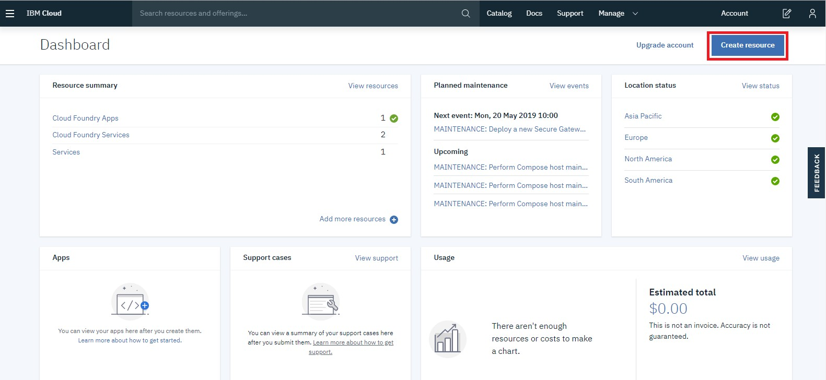

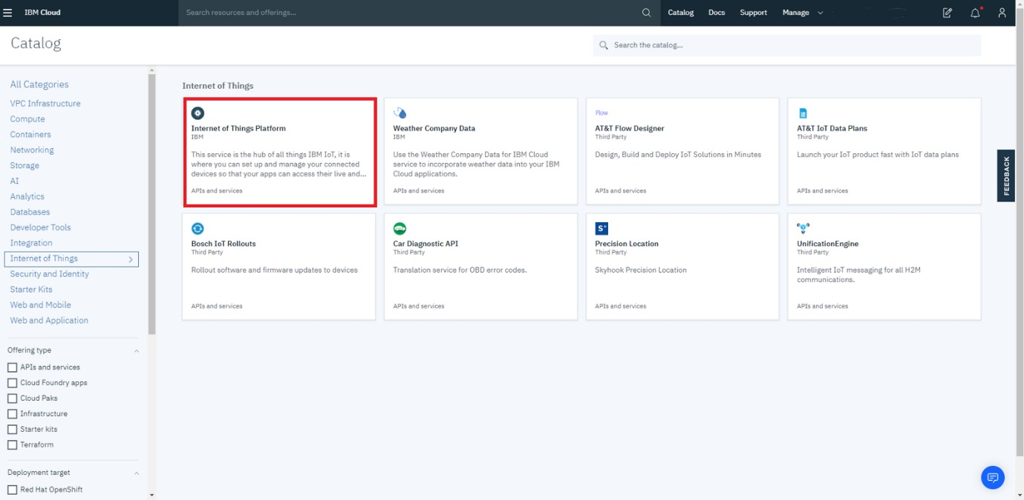

* Once you have created the IoT resource, you can launch the [IBM Watson](https://cloud.ibm.com/services/iotf-service/crn%3Av1%3Abluemix%3Apublic%3Aiotf-service%3Aeu-gb%3Aa%2F329f1ef9f4bc478e8cf8a687bc956df0%3Aa9a52fa1-70ea-44c3-bb81-bede4ce2d675%3A%3A?paneId=manage) [IoT Platform](https://cloud.ibm.com/services/iotf-service/crn%3Av1%3Abluemix%3Apublic%3Aiotf-service%3Aeu-gb%3Aa%2F329f1ef9f4bc478e8cf8a687bc956df0%3Aa9a52fa1-70ea-44c3-bb81-bede4ce2d675%3A%3A?paneId=manage):

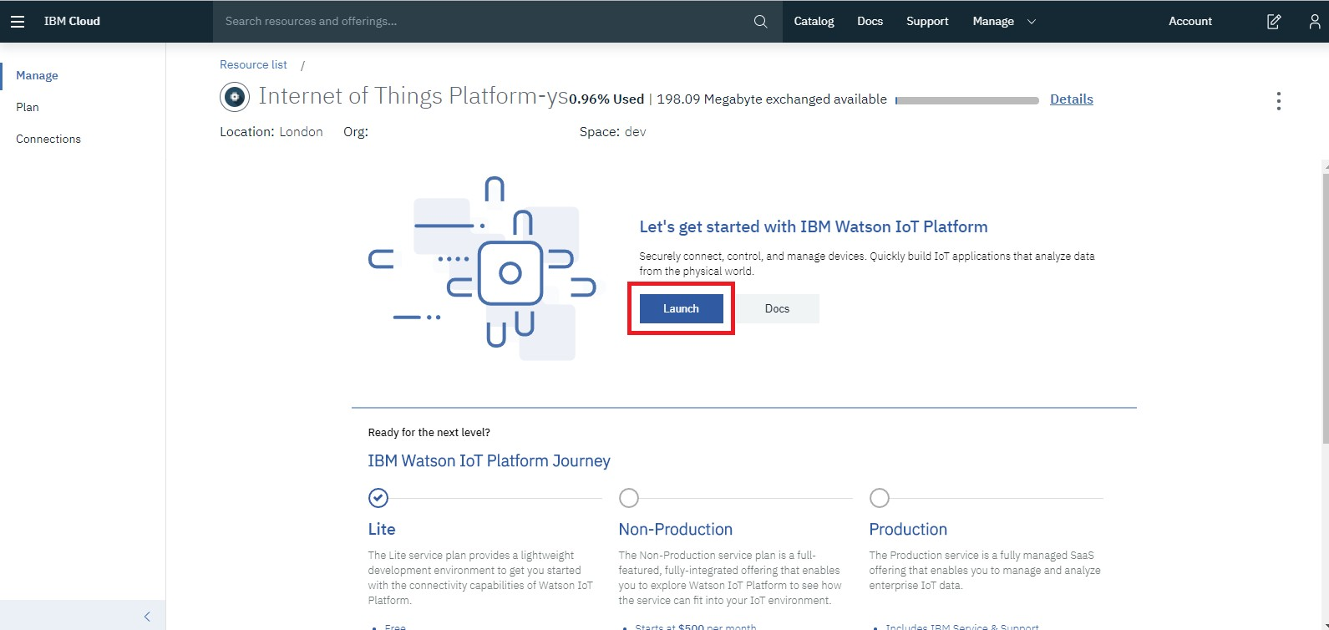

## Step2: Register your device on your IoT Platform

In this step we will create a device twin in Watson IoT Platform service that represents your physical device.

Watson IoT Platform service includes a **device twin** feature. This cloud- based digital representation of your device is connected to Watson IoT Platform service. Once it is defined and instantiated, the device twin provides a consistent means of interacting with your device from the IoT

hub.

* Within your IBM Watson IoT Platform, select **Devices** tab and click on

**Add Device** button.

Step3: Configure Tap Link to handle IBM Watson connectivity

The STM32 Blue Pill board that is included in the Tap Link Primer Evaluation Kit is pre-programmed with the STM32_Sensor application which demonstrates a few simple features like blinking the LED, measuring the internal temperature and voltage etc. In this guide, we will configure Tap Link to send some information to Watson IoT Platform.

Launch **IoTize Studio** and open **sensor demo. iot** config file installed in the

**Sensors_STM32_Demo** subdirectory of the installed examples. Select **IoT Platform (MQTT)** and setup the configuration:

* + Set **Enable Relay** to **Yes**.*This allows the tap to use MQTT to receive LWM2M commands*
  + Select **IBM Watson** in **IoT Platform**
  + **Cloud Profile**: A specific profile to control access privileges of the connected 'IoT Platform'.
  + **IBM Watson information**: Provide the previously created **Device Twin** information to enable TapNLink to connect directly to your Watson IoT Platform.
  + **Organization ID**
  + **Device Type**
  + **Device ID**
  + **Authentication Token**
  + **IBM Watson messaging root certificate**: If you set up a Root CA to aunthenticate your devices, set it here. Leave it empty other